

Ain Shams University
Faculty of Engineering
International Credit Hour Engineering Programs
ICHEP
Object-Oriented programming
Hotel Reservation System
Submitted by
Joyce Sherif 25P0250
Moaz Sherif 25P0379
Amy George 25P0078
Yasseen Ahmed 25P0298

Project Objective:
The primary objective of Milestone 2 was to enhance the existing backend by implementing a fully interactive Graphical User Interface (GUI) using JavaFX. This phase also integrated advanced concepts such as multi-threading for real-time updates and basic client-server networking via Java Sockets.

JavaFX Graphical User Interface:
The GUI was developed following the Model-View-Controller (MVC) pattern to ensure a clean separation between the application logic and the presentation layer.

Implemented Screens
- Login / Register: Includes validation for new guest registrations and secure login for both guests and staff.
- Guest Dashboard: A personalized view for users to manage their profiles, check balances, and see active reservations.
- Room Browsing: An interactive catalog allowing users to filter rooms by type, price, and available amenities.
- Reservation Management: Functional interfaces to create new bookings, view history, and cancel existing reservations.
- Checkout / Payment: A dedicated screen to select payment methods (Cash, Credit Card, or Online), view the final invoice, and confirm payment.

UI/UX Enhancements
- Layout Management: We utilized BorderPane, GridPane, VBox, and HBox to create a responsive and organized layout.
- FXML & CSS: At least three screens were designed using FXML files for structural clarity. A global CSS stylesheet was applied to provide a consistent, professional visual identity.
- User Feedback: All actions trigger appropriate feedback via JavaFX alerts, dialogs, or status labels to guide the user.

Advanced Features (Bonus)

Multi-threading
To prevent UI freezing during heavy operations, we implemented:
- Background Loading: Reservations and room data are loaded asynchronously using JavaFX Task classes.
- Real-time Updates: Room availability refreshes automatically without interrupting the user's workflow.
- Thread Safety: All UI updates from background threads are wrapped in Platform.runLater() to maintain thread safety.

Client-Server Networking
A live chat feature was implemented using ServerSocket and Socket classes:
- Concurrent Handling: The server utilizes threads to handle multiple guest clients simultaneously.
- Real-time Communication: Guests can send messages to the receptionist and receive instant replies within a dedicated chat window.

Test Cases:
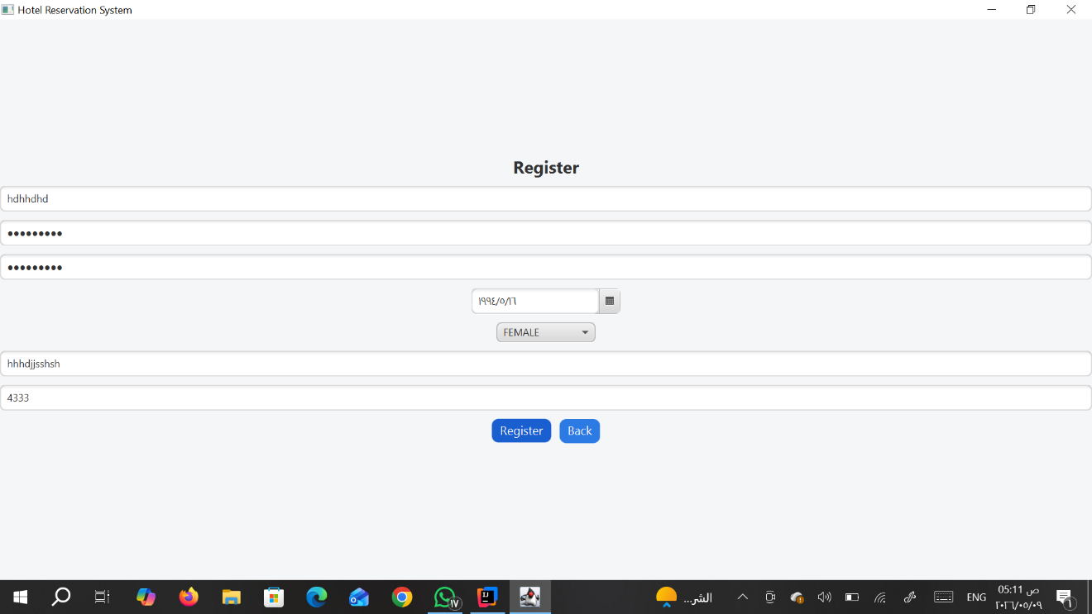
Initial Registration Interface and Field Layout
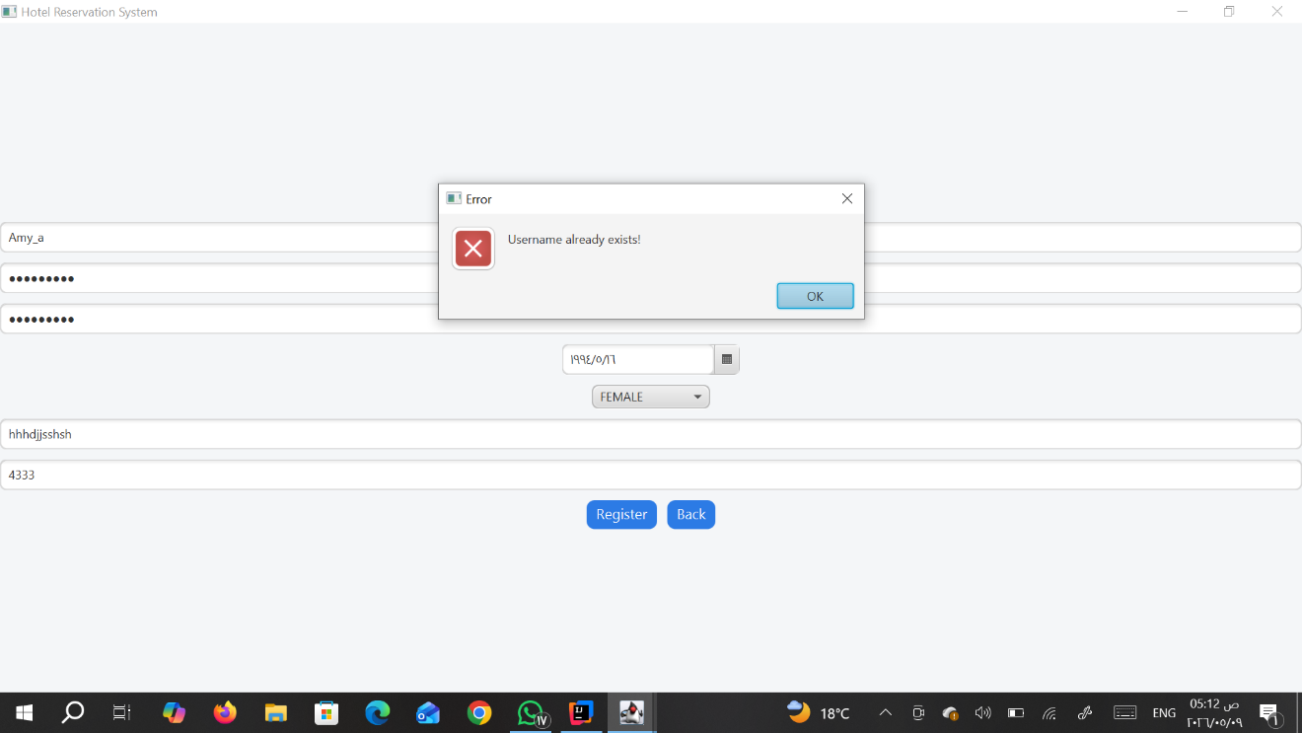
Error alert triggered when Username already exists
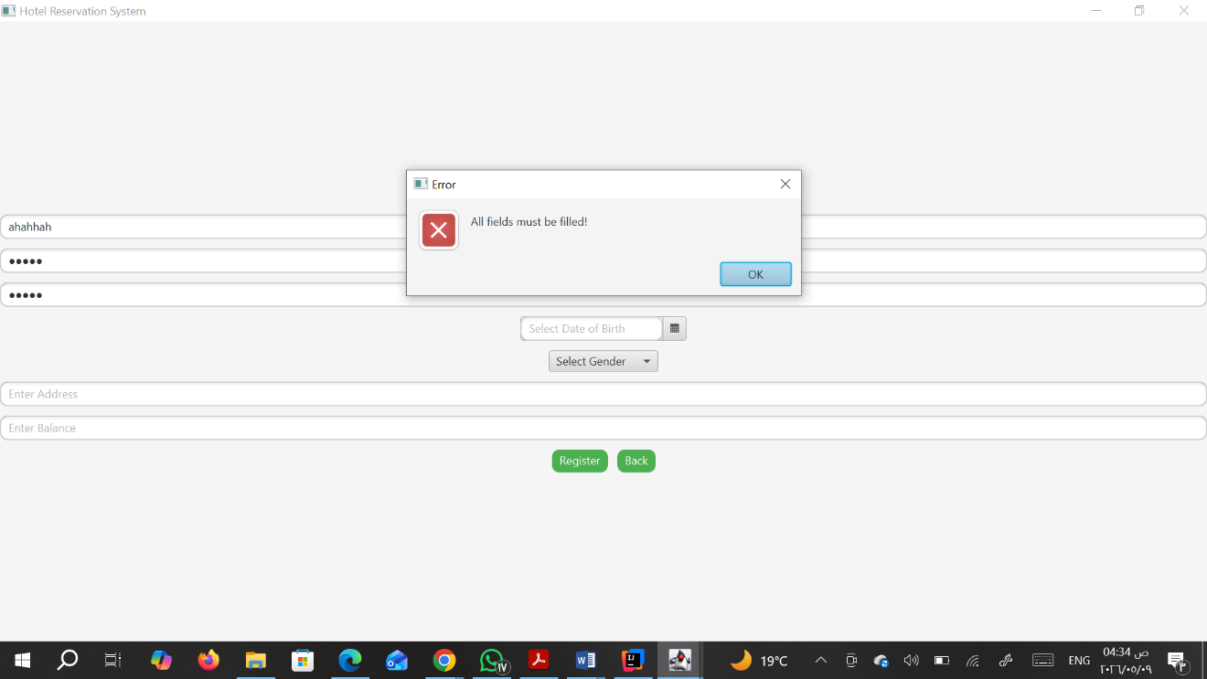 Validation alert for mandatory fields: All fields must be filled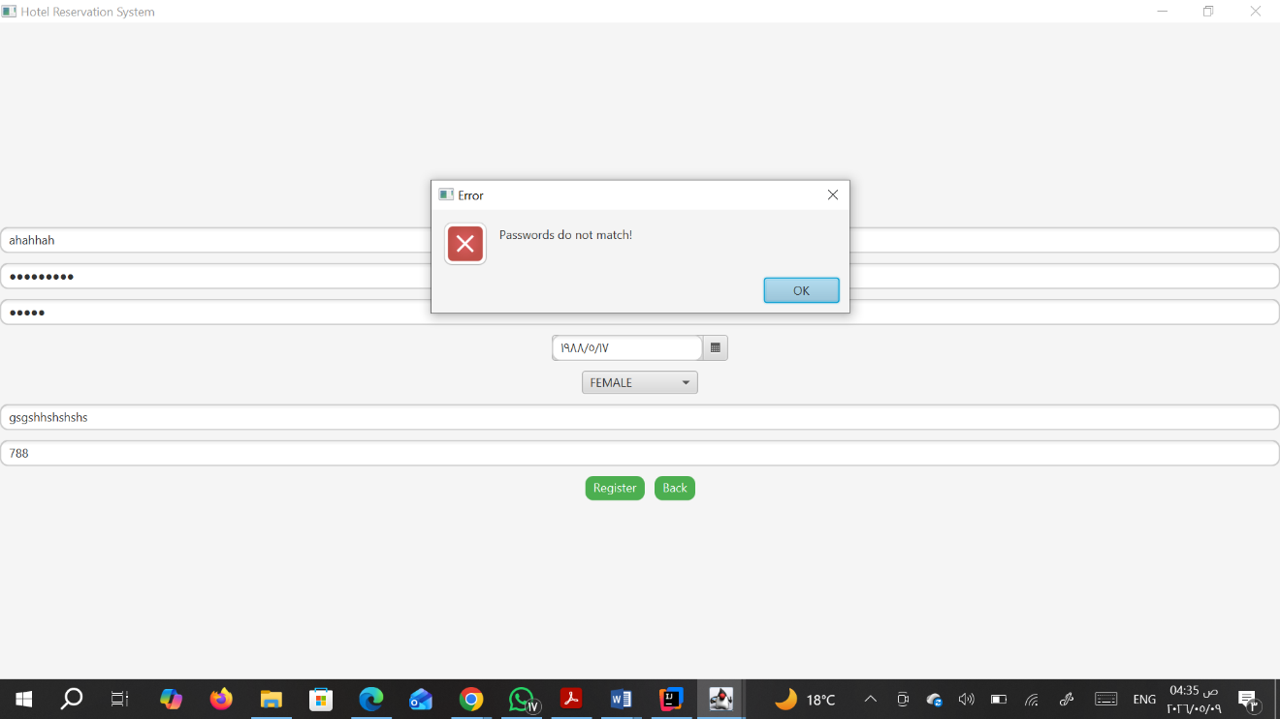
Registeration validation
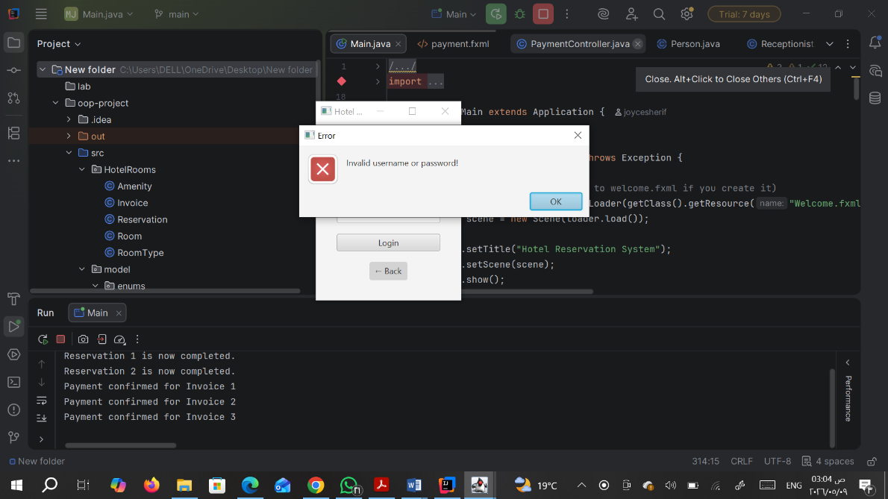
Demonstrates the system's input validation and custom exception handling by showing an error alert when an invalid username or password is entered. 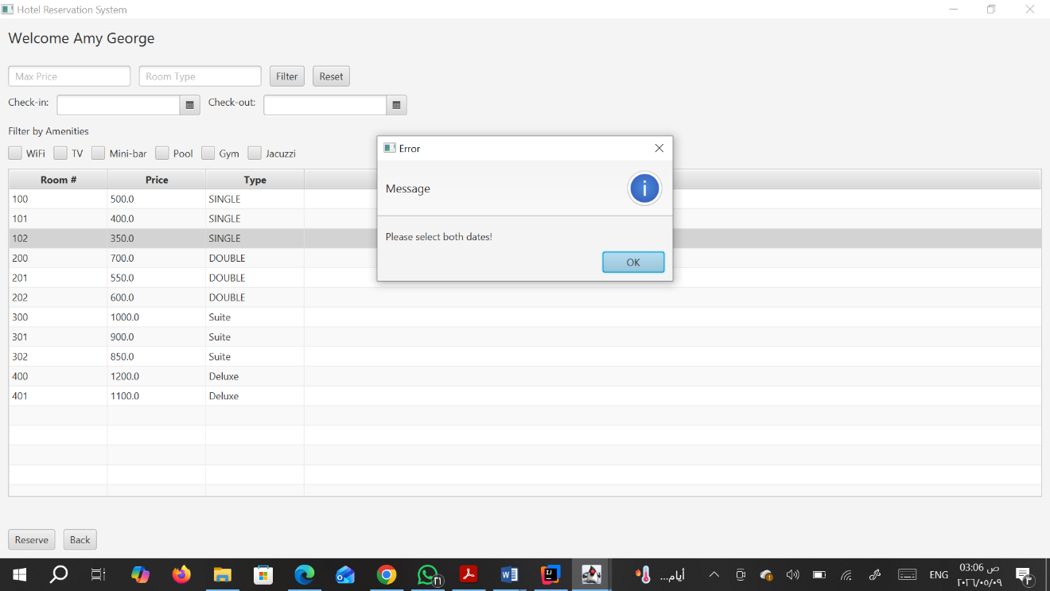
Shows a validation alert in the Room Browsing screen, reminding the guest that both check-in and check-out dates must be selected before they can view available rooms.
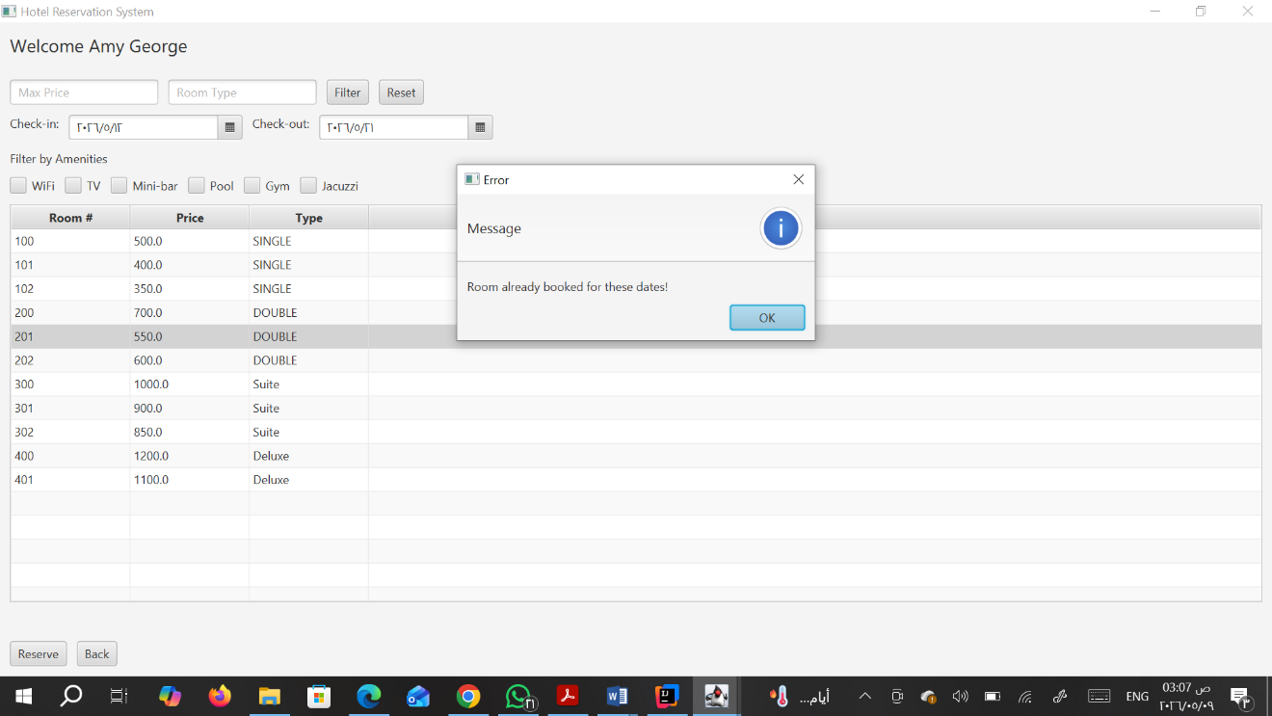
Illustrates the RoomNotAvailableException being caught, showing an error message when a user attempts to book a room that is already reserved for those specific dates.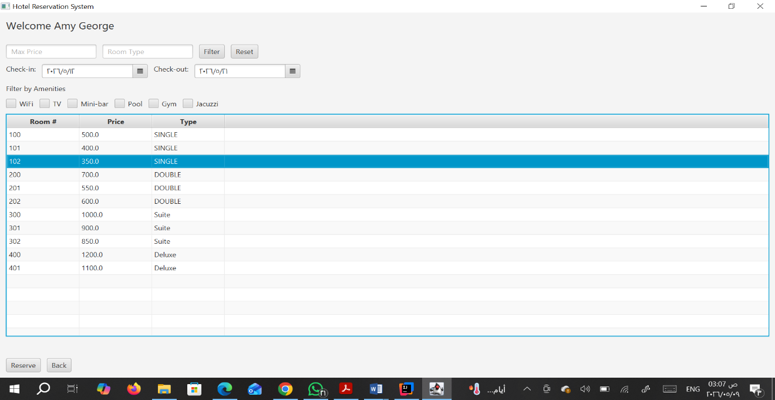
Displays the Room Browsing interface where a guest has successfully filtered and selected a specific room (e.g., Room 102, Single) to begin a reservation
.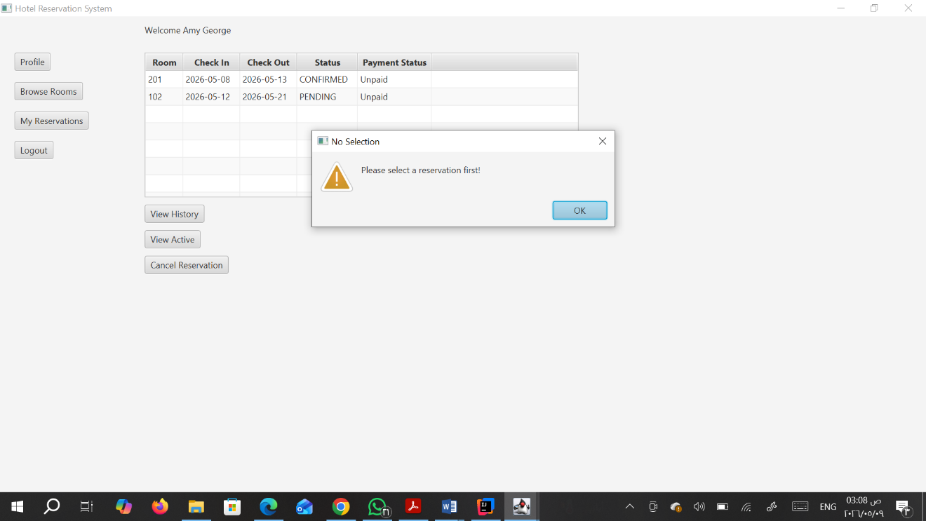
Shows an alert in the My Reservations dashboard indicating that a user must first select a reservation from the table before they can view its history or cancel it.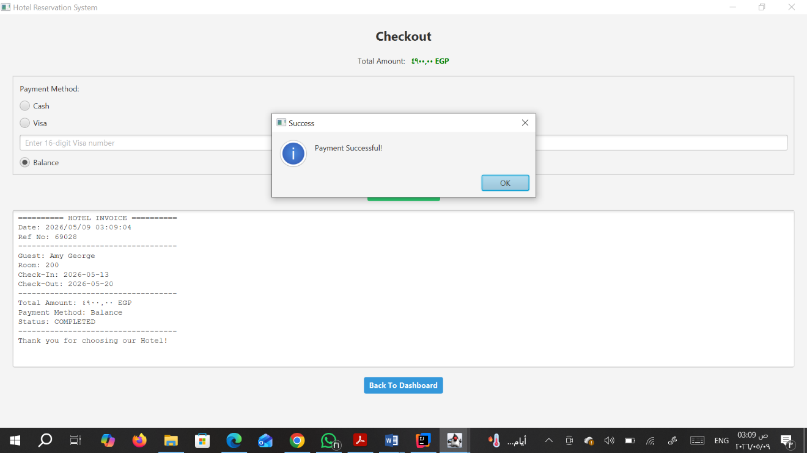
Confirms a successful transaction via the Checkout screen using the "Balance" payment method, showing the generated digital invoice.

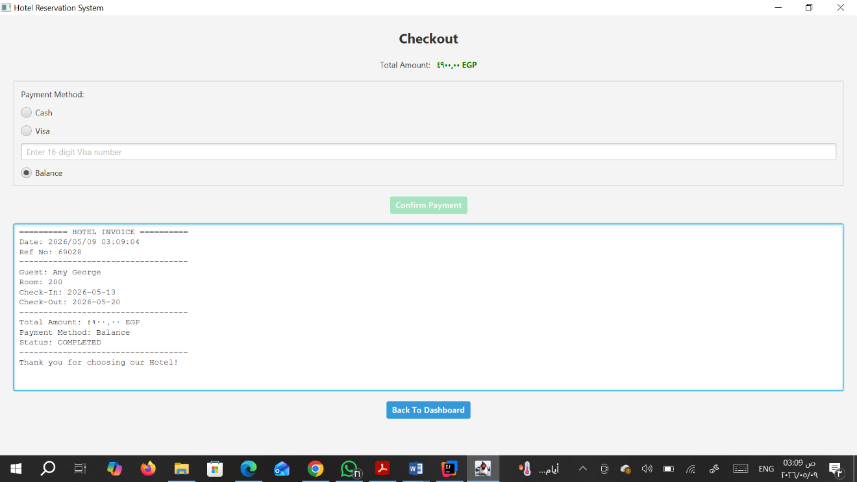
A detailed view of the Hotel Invoice for a completed stay, displaying the guest name, room number, total amount in EGP, and the "Completed" status.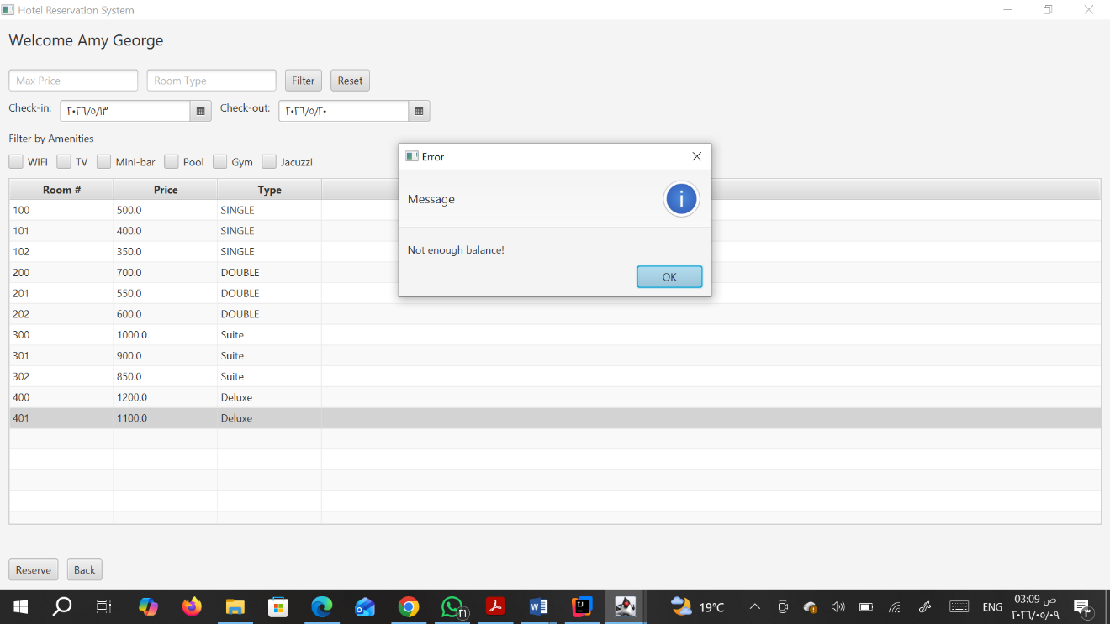
Demonstrates financial validation by showing an error alert when a guest's current balance is lower than the total amount required for a booking.
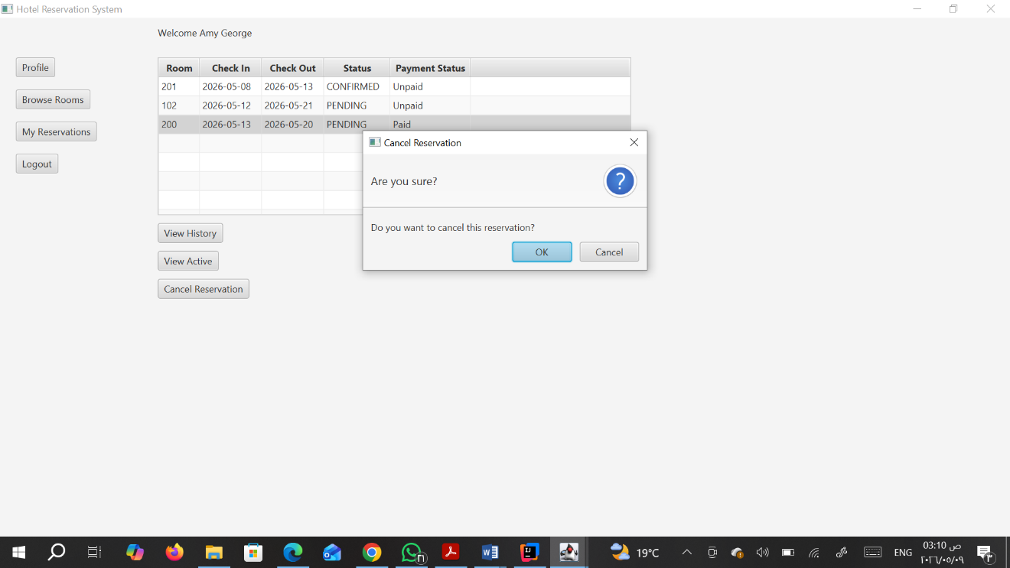
Shows the confirmation dialog ("Are you sure?") triggered when a user clicks Cancel Reservation, ensuring actions are intentional. 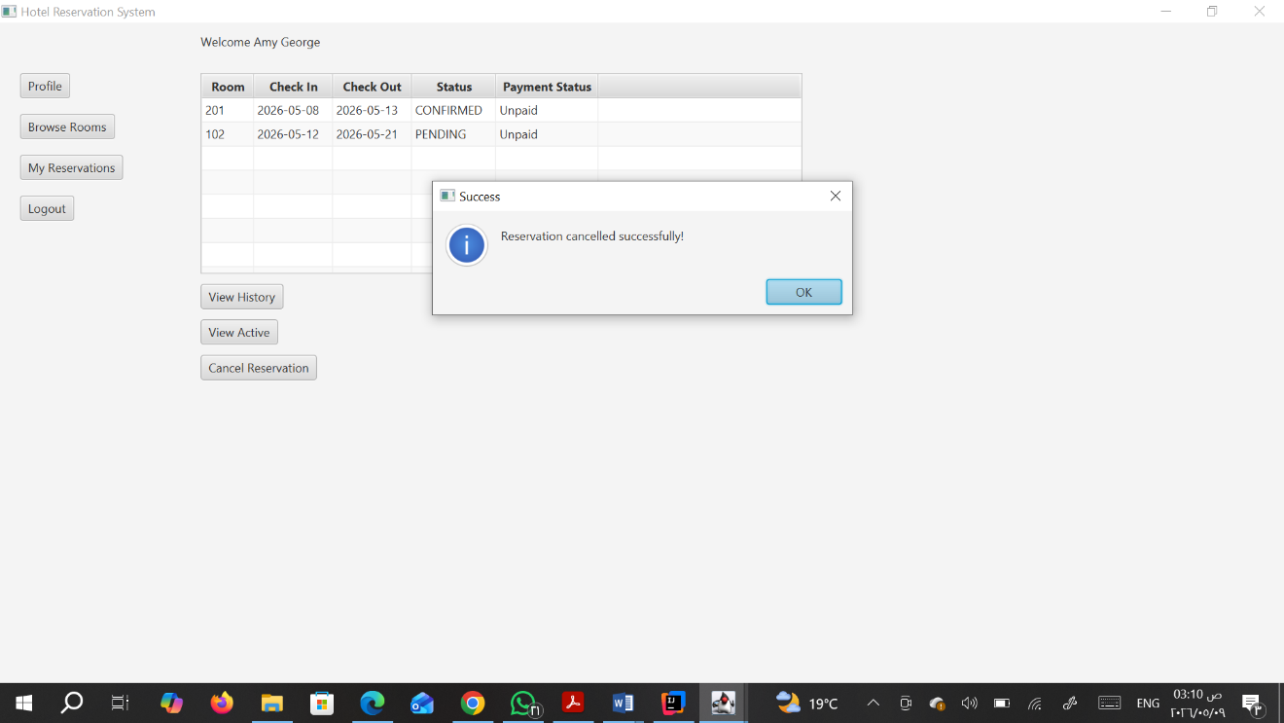
Confirms that the reservation was successfully removed from the system and the status has been updated.
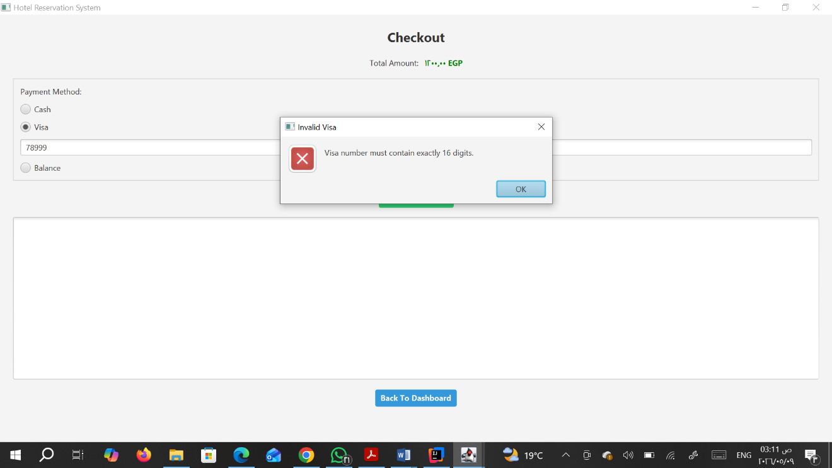
Shows an error alert for the Credit Card payment method, requiring exactly 16 digits for a valid Visa number.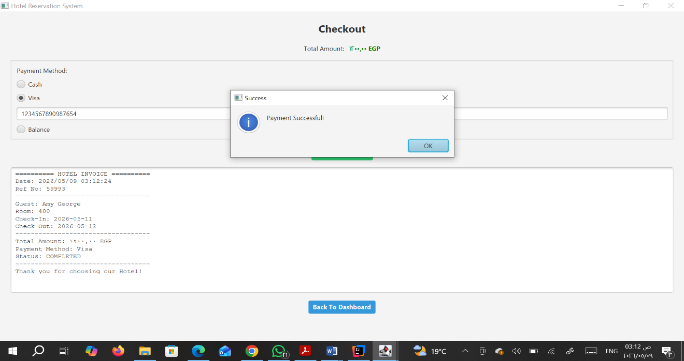
Confirms a successful credit card transaction after a valid 16-digit number was provided.
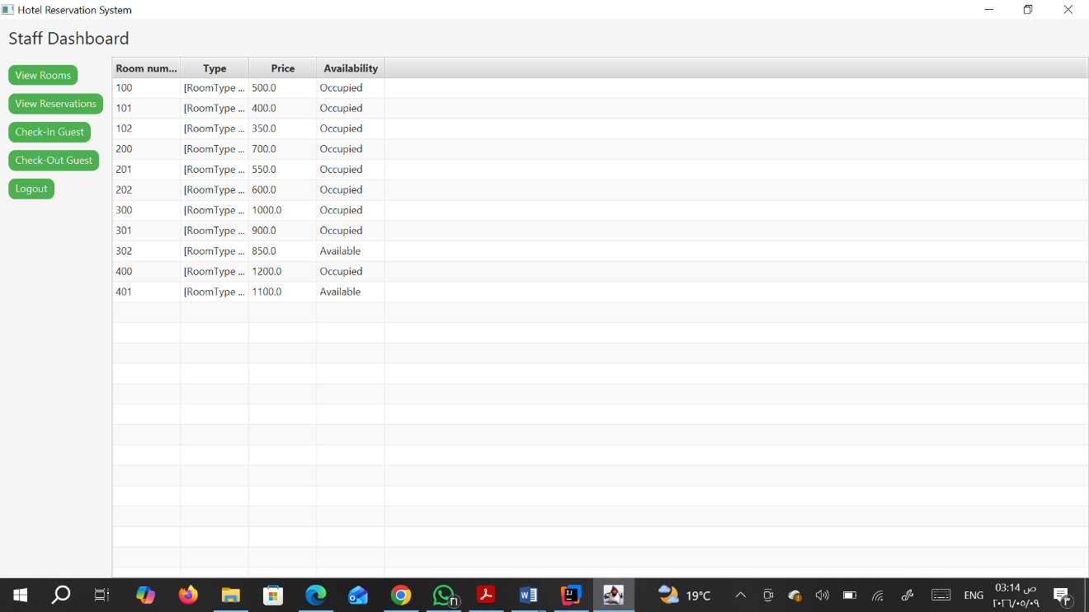
Displays the receptionist's view of the Room Management screen, showing the live occupancy status (Occupied vs. Available) for all rooms.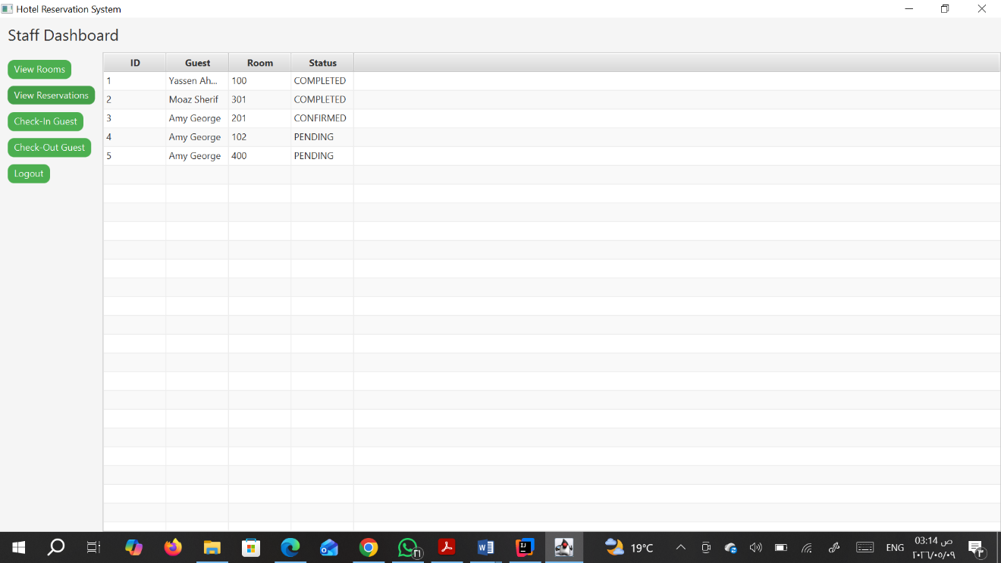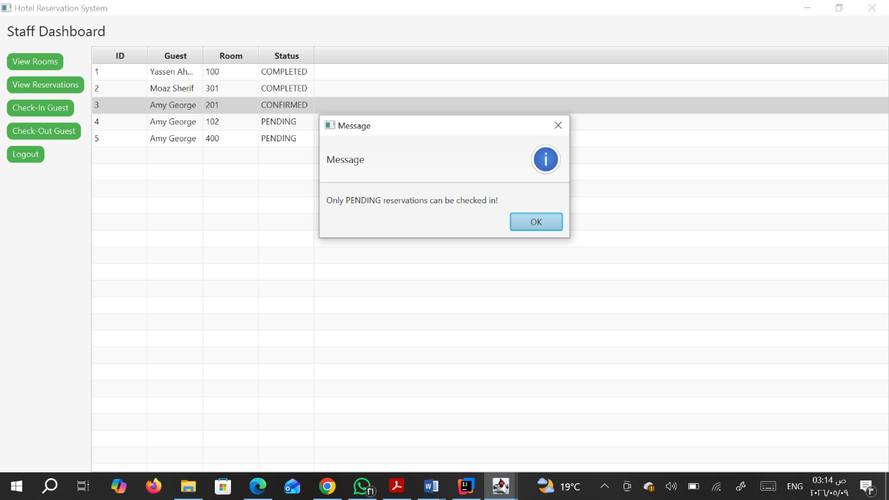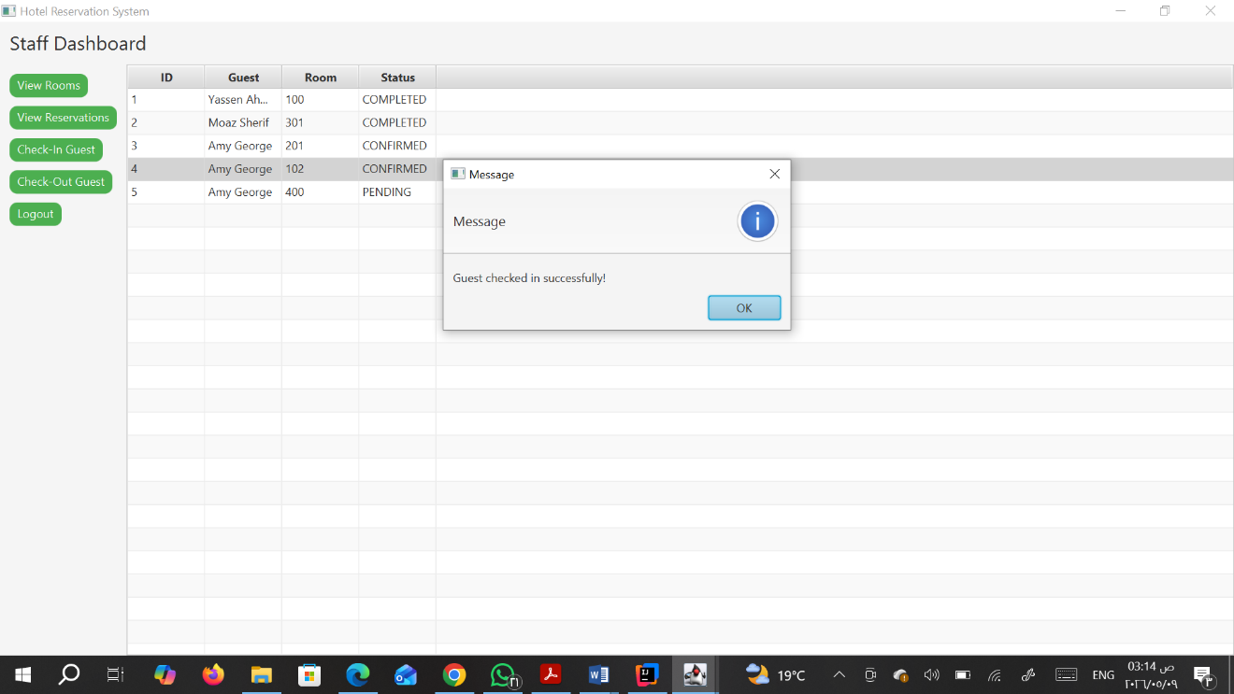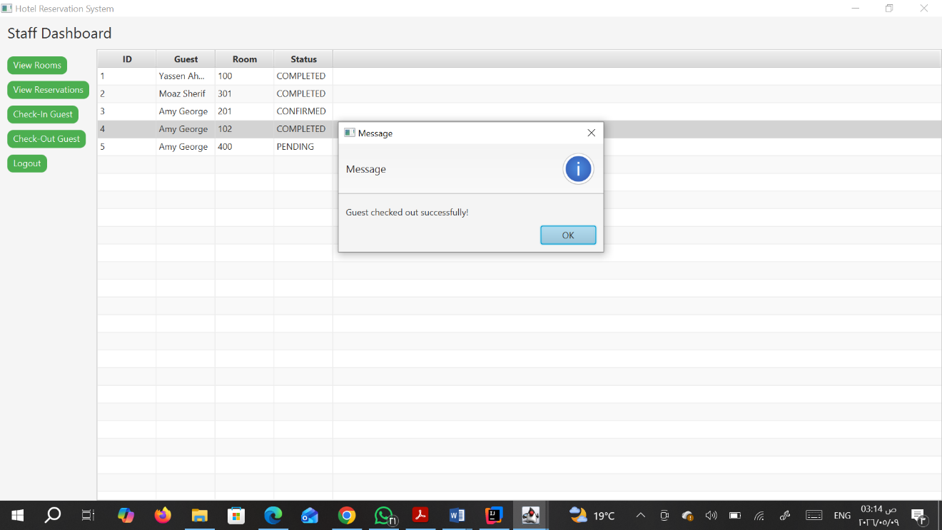

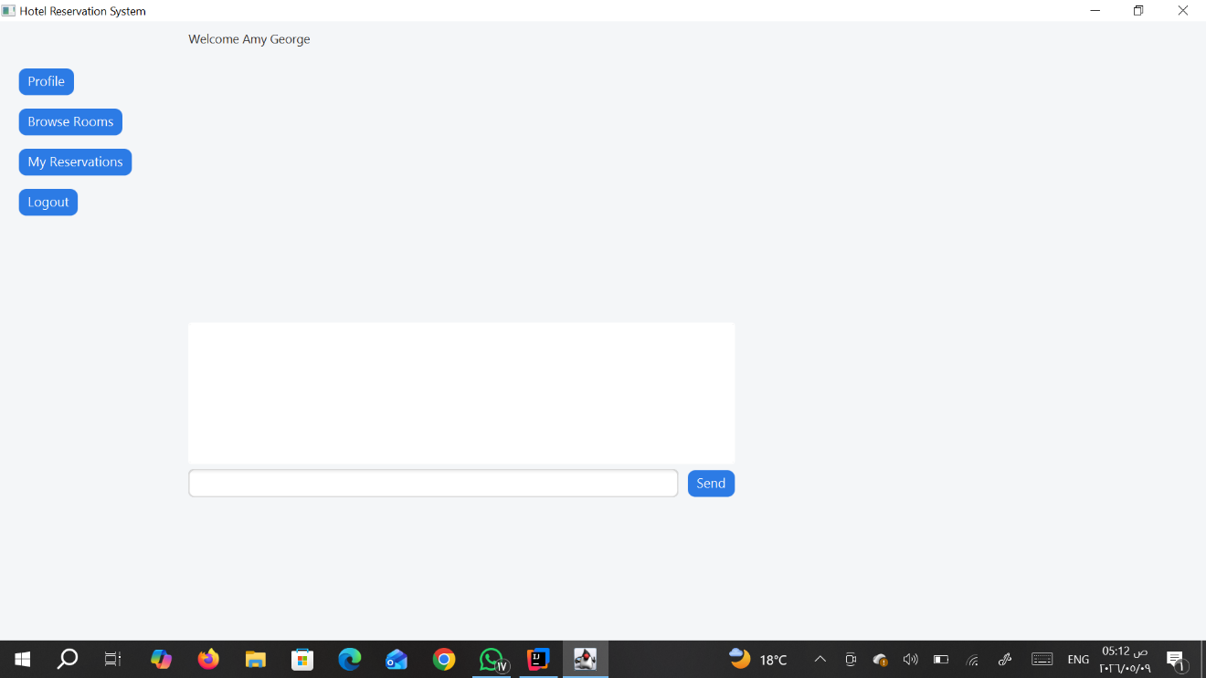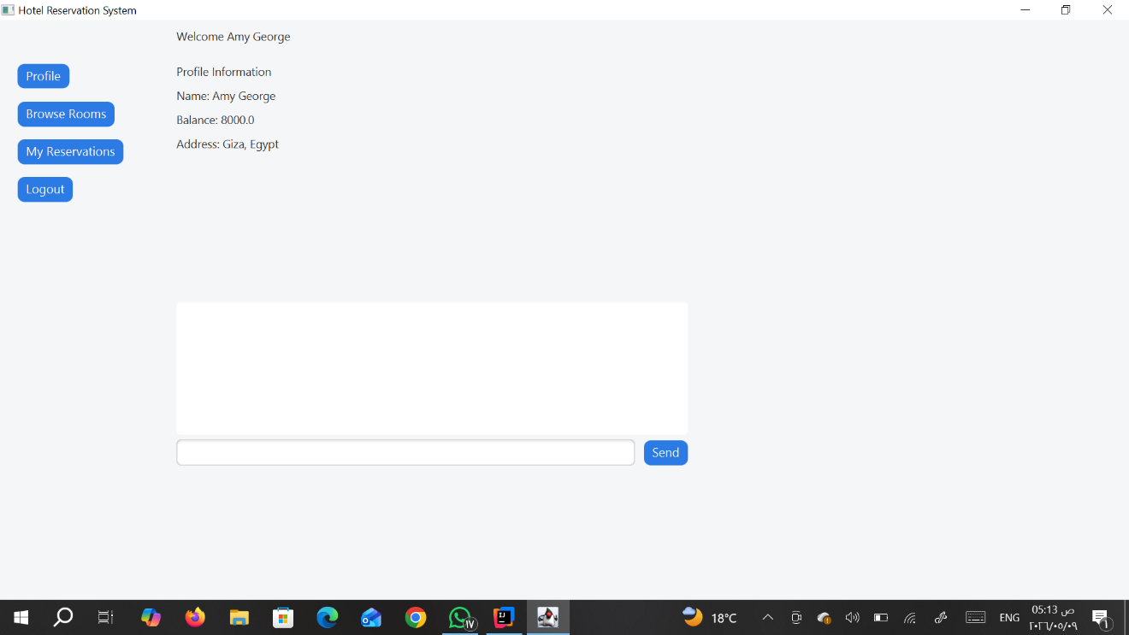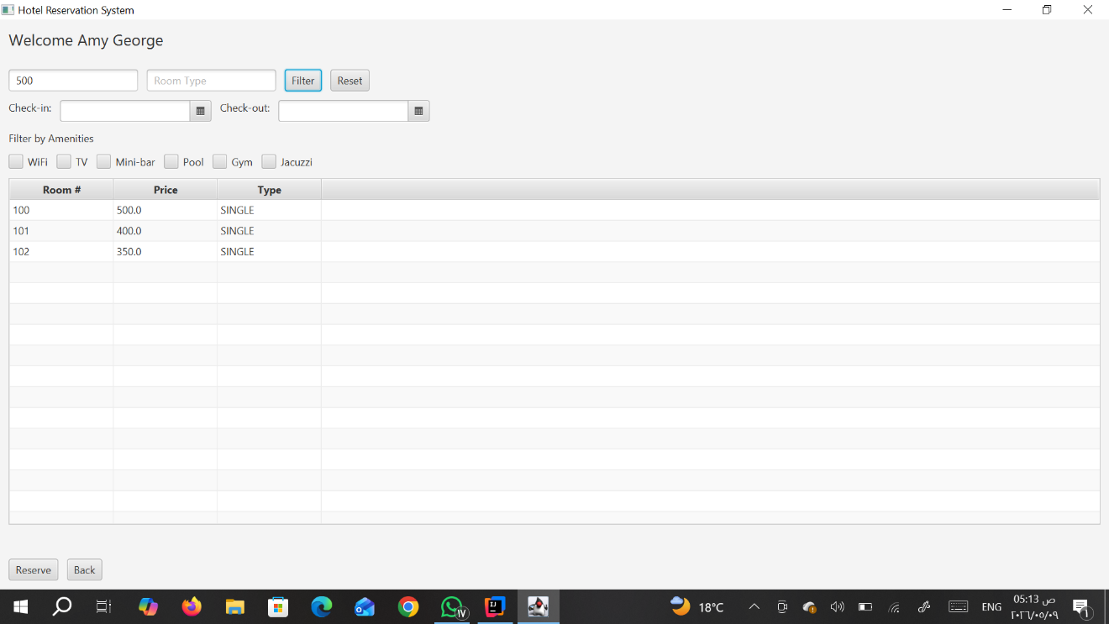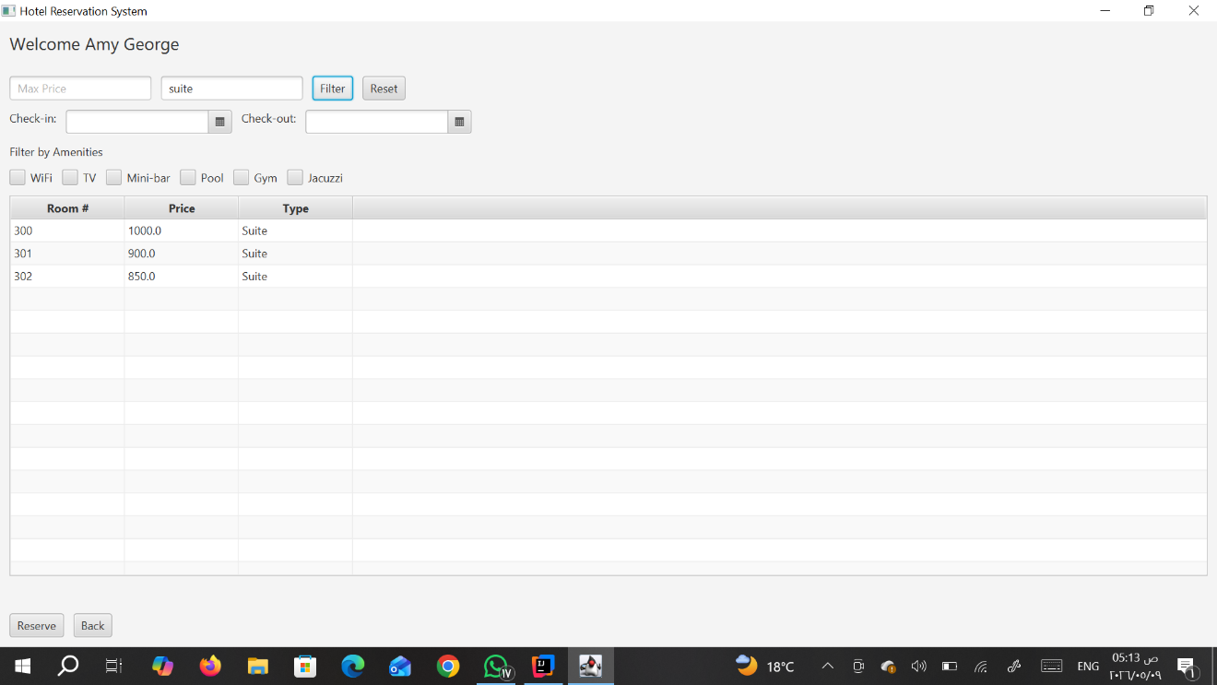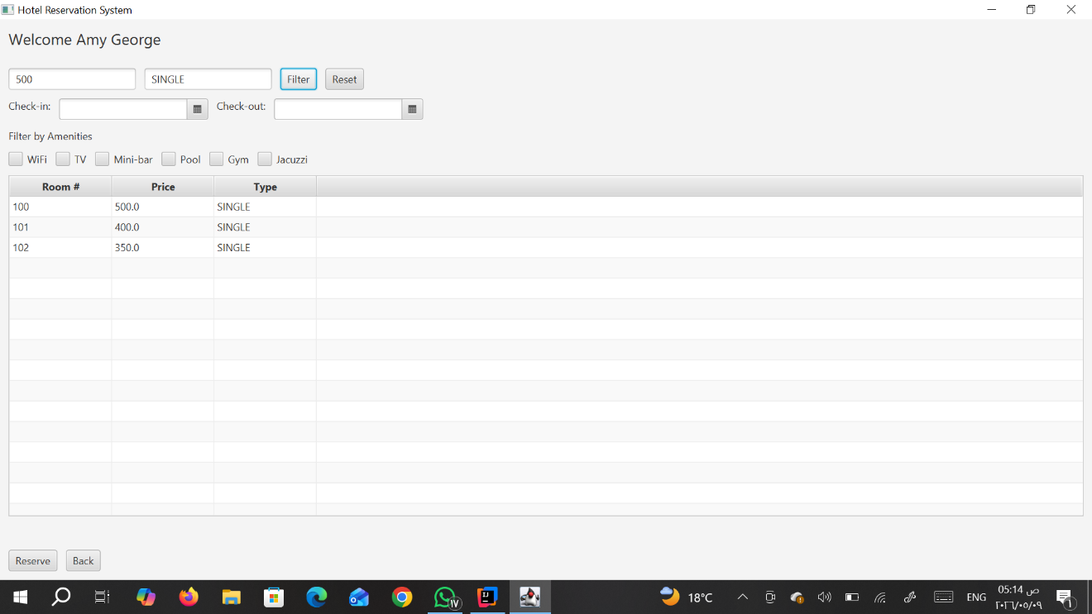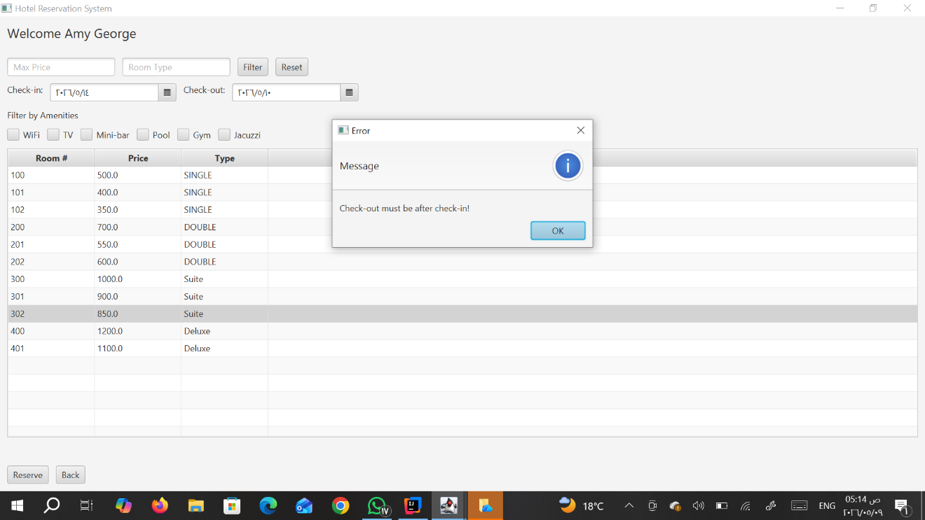
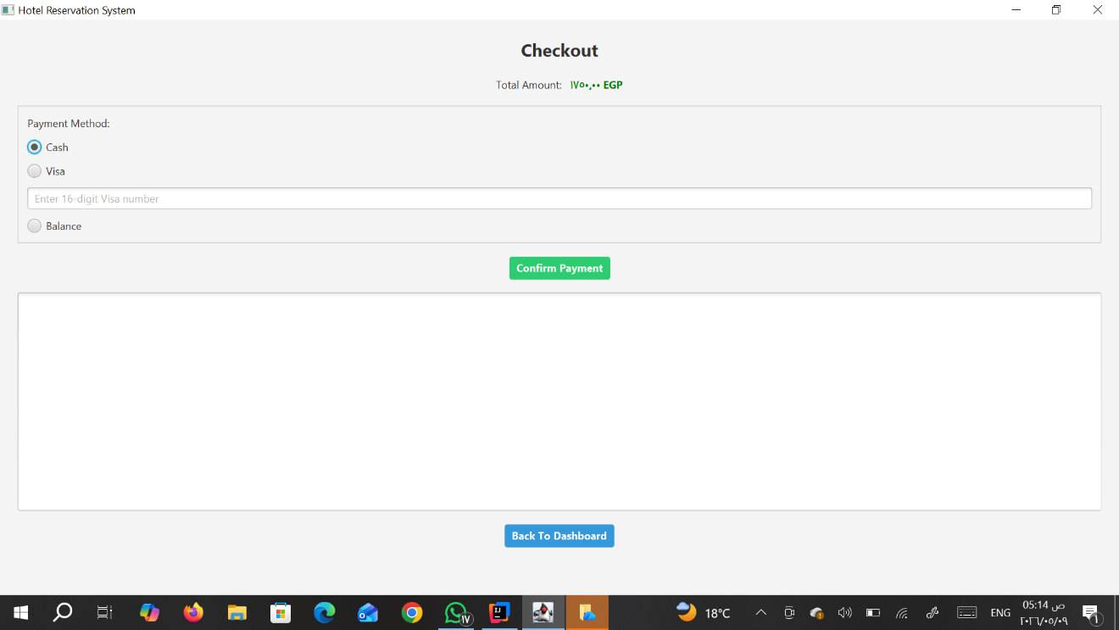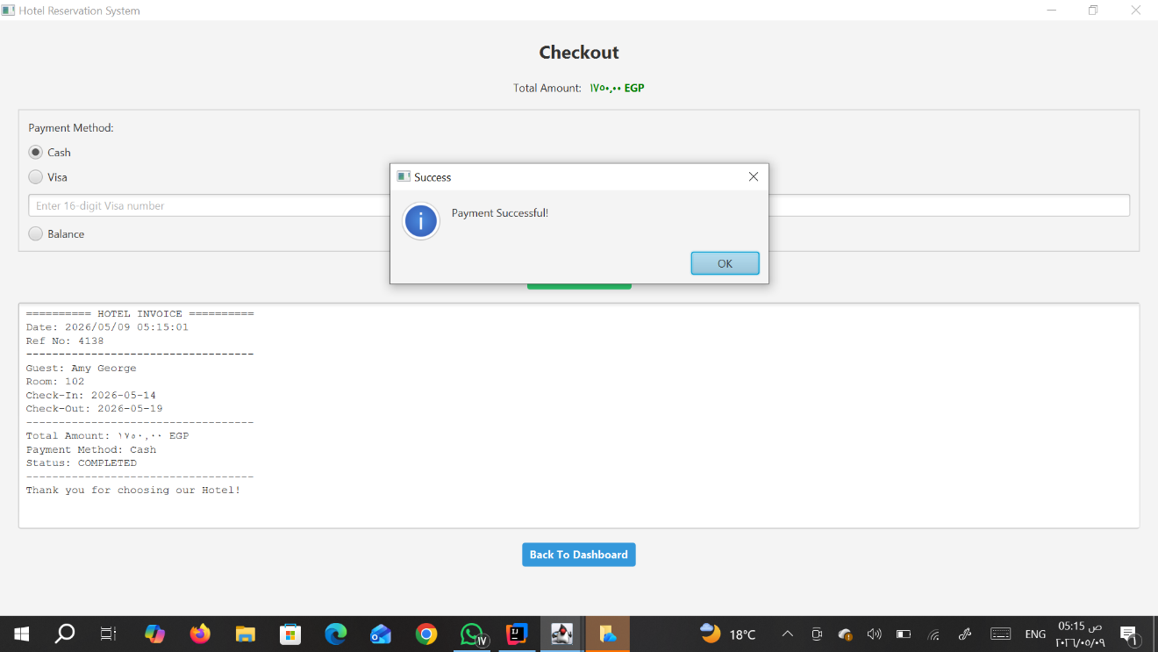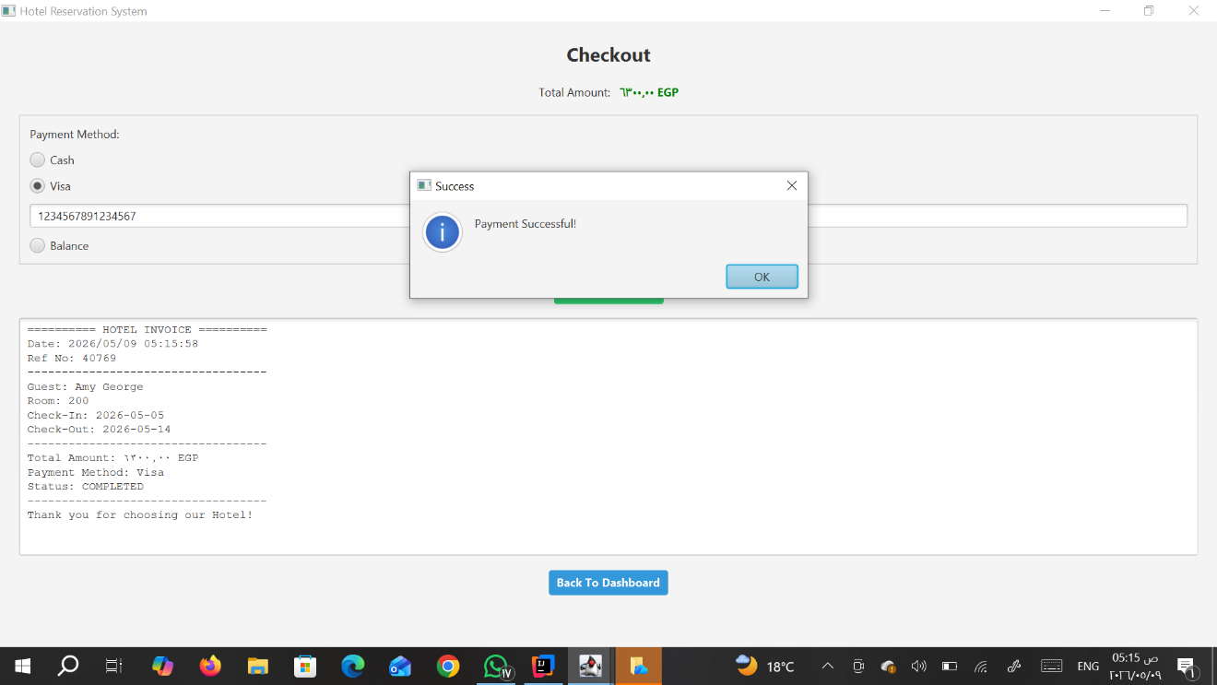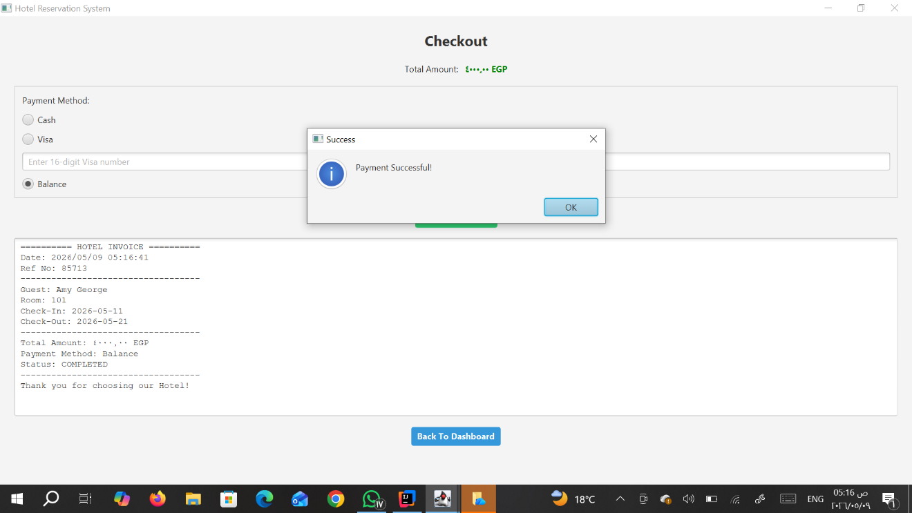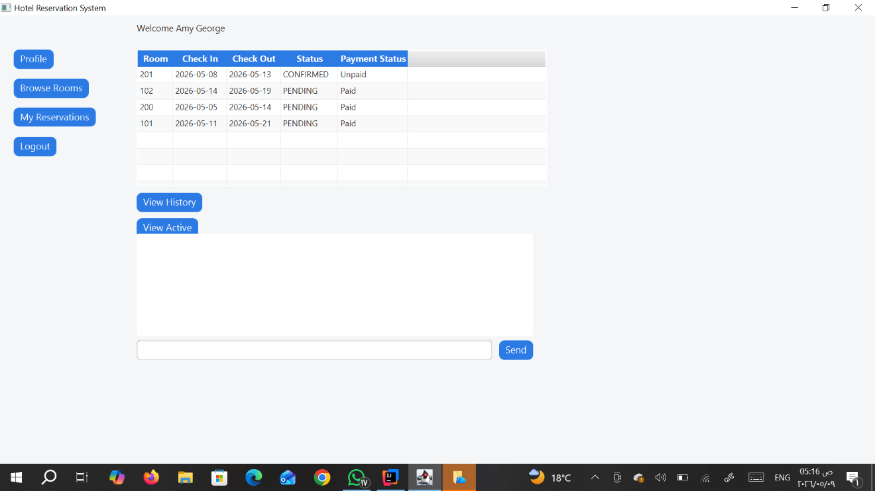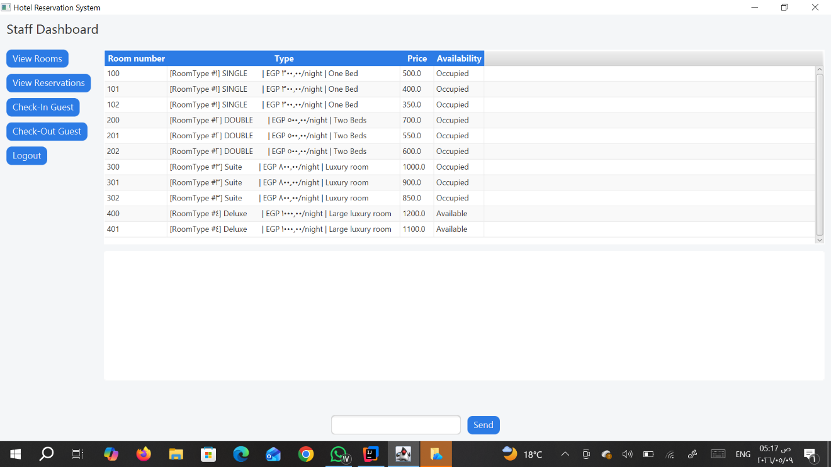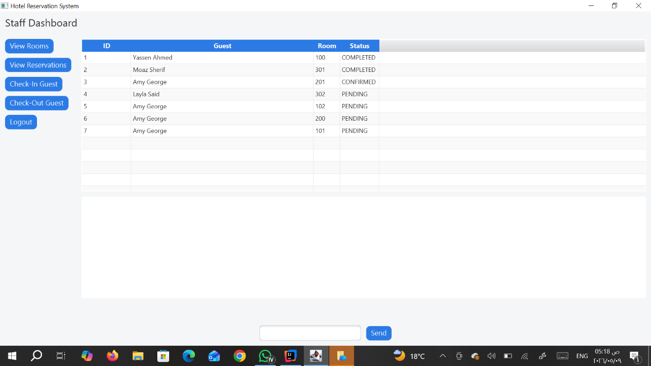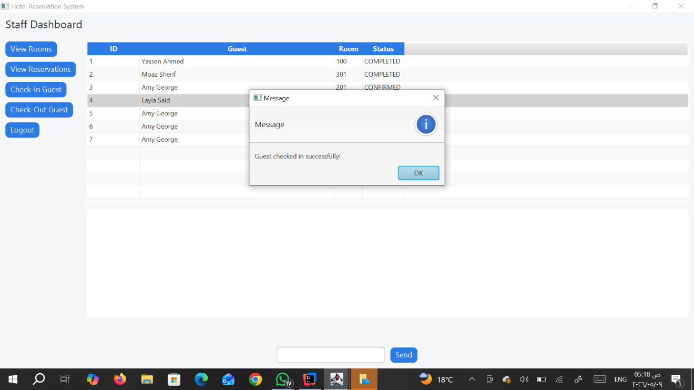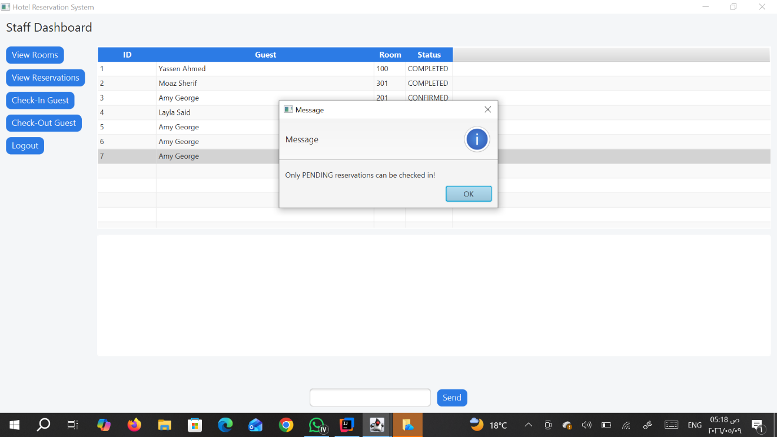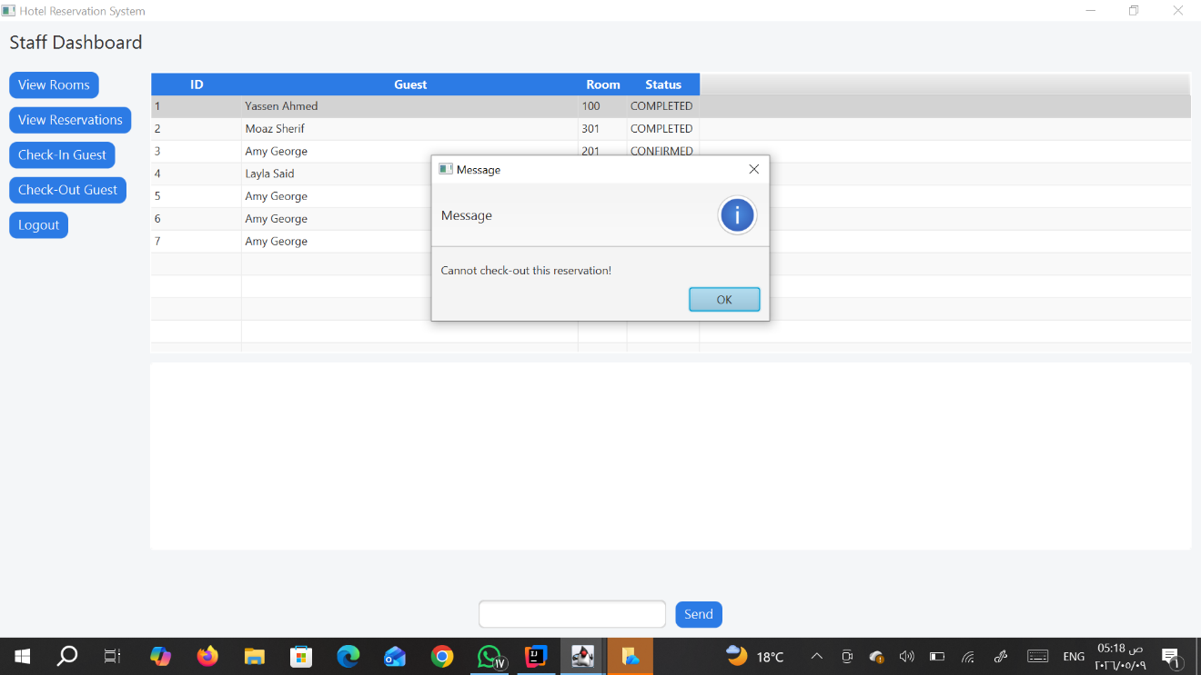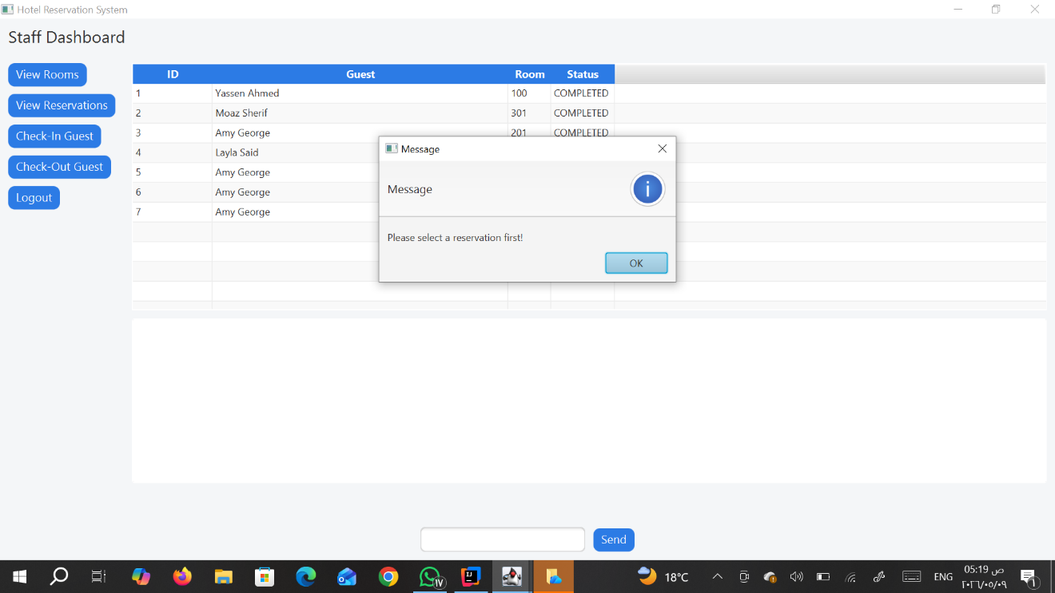
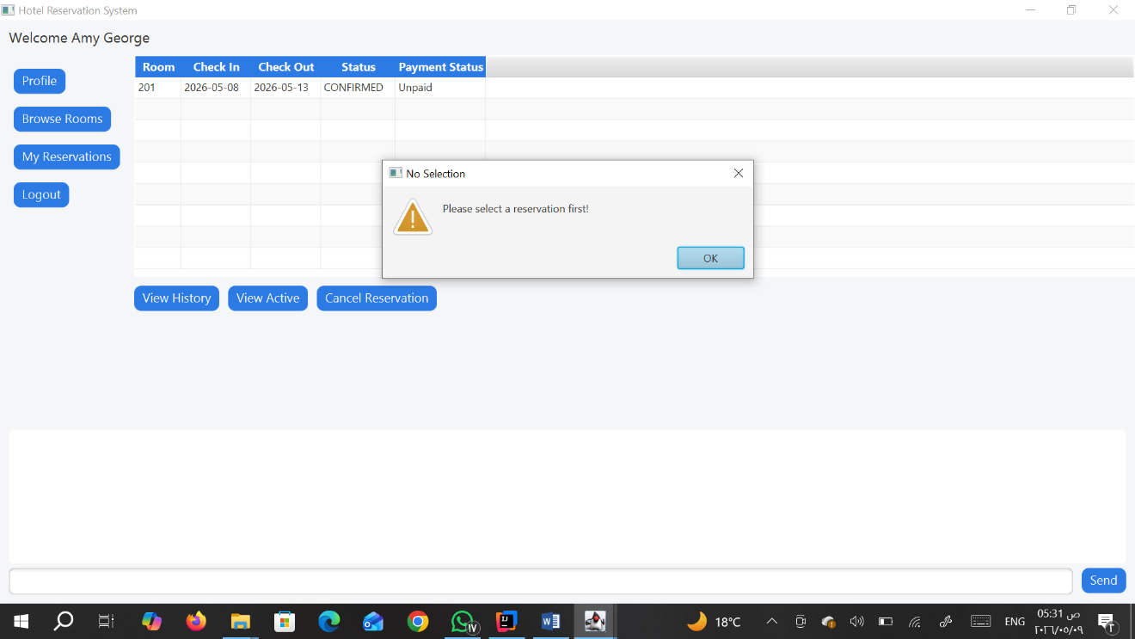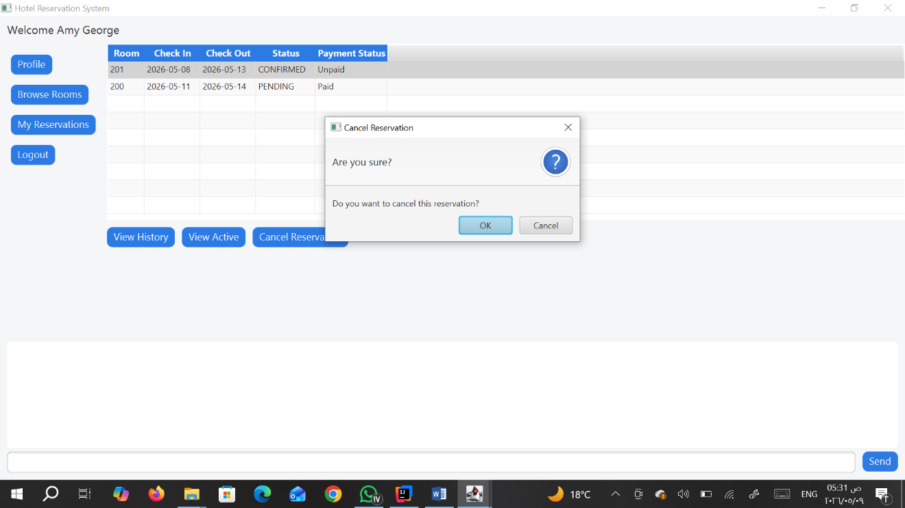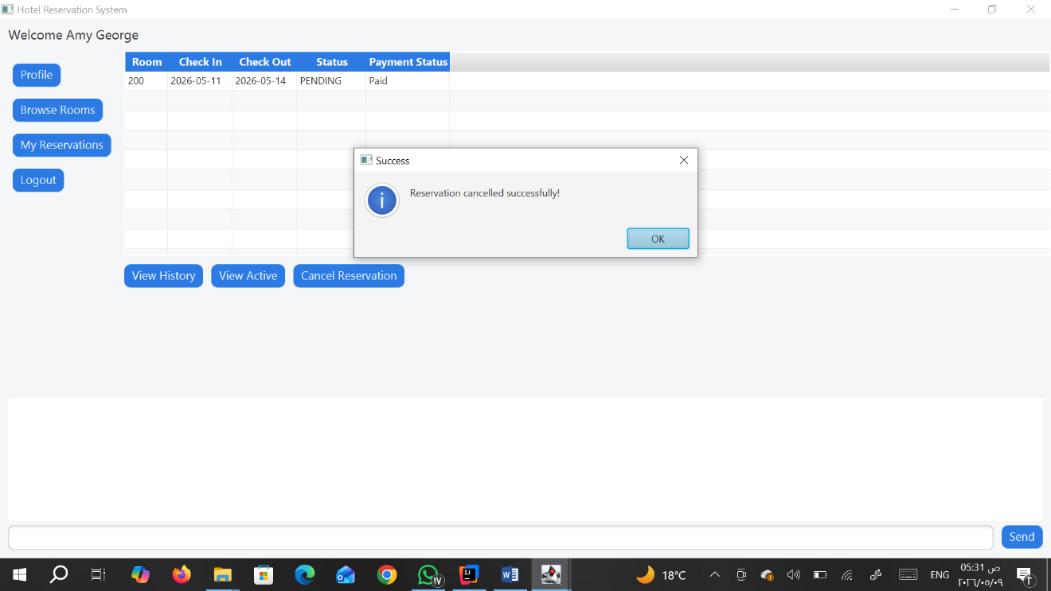
Design Decisions:
Scene Switching: We implemented smooth navigation using a centralized Stage controller to switch scenes efficiently.
Custom Exceptions: We maintained the custom exception handling from Milestone 1 (e.g., RoomNotAvailableException) to ensure the GUI accurately reports backend errors.
Detailed Analysis and Design:
  - GuestDashboardController:
GuestDashboardController acts as the logic component of the guest-oriented module of the Hotel Management System using JavaFX to create an engaging and safe environment for the user. With the application of the MVC architecture, the controller can effectively handle the session of the guest by inserting personalized information on the interface like account balance and profile information and managing sophisticated data representation with the use of TableView. The controller can smoothly switch scenes with internal panes to navigate to room viewing while handling the reservation process by creating, retrieving, updating, and deleting reservations including filtered views of current and past reservations. Also, it is important to note that the controller makes sure of operational accuracy through the implementation of data persistence using singletons, null-safe validation, and modal dialogues.

  - LoginController:
LoginController is used as the main security entry point for Hotel Management System through user authentication and authorization based on role using JavaFX technology. Using the MVC paradigm, the login controller is used to validate user credentials through handleLogin method that uses the singleton HotelDataBase object in order to validate the user credentials against the database. In the event the credentials match those stored in the database, dynamic polymorphism is used to determine whether an object of type Guest or Staff has been authenticated before using FXMLLoader to inject the user object into the dashboard controller depending on the type. The injection process involves extensive user interface management, including loading of external CSS files to ensure visual consistency of the application as well as moving the primary stage to the correct functional component of the program.

  - PaymentController:
The PaymentController controls the financial transaction layer of the Hotel Management System, offering a secure and validated way of making final bookings of rooms. The controller acts as a highly reliable element of the JavaFX framework in processing multiple channels for making payments through thorough validation techniques for credit card payment (Regex-based 16-digit validation) and account balance payments. The PaymentController performs a series of activities, including the deduction of the balance in real time, transaction simulations, and finally, generating an invoice in digitized format. Through the Invoice and Reservation entities, the PaymentController ensures consistency in data handling through programmatic updates to the booking state after successful transactions and a digitized read-only invoice in a TextArea format. Lastly, the PaymentController allows a seamless transition back to the guest’s dashboard by transferring scenes while retaining the guest session using modal alert popups to navigate the checkout procedure.

  - RegisterController:
RegisterController is the class responsible for user onboarding process in the Hotel Management System and offers an extensive implementation of data validation and object creation mechanisms using the JavaFX platform. Working under the MVC design pattern, this controller controls the registration process by applying several stringent business rules, such as checking user age using the Period API to confirm they are at least 18 years old, imposing password strength constraints, and checking the account balance format. In addition, this controller interacts directly with the HotelDataBase singleton object to avoid duplicate username entries and validates all required fields, such as gender and date of birth, are adequately filled before instantiating the object. Once all the data validation rules pass successfully, this controller instantiates a Guest object and assigns default values to its RoomPreferences object attributes. Finally, this controller stores the newly created guest's profile to the global HotelDataBase object and provides proper feedback to the user using modal Alert dialogs while handling scene changes using the SceneManager class.

  - RoomsController:
This controller is responsible for the functionality of the room selection and reservation inventory module within the Hotel Management System acting as a complex mediator between the guest and the assets of the hotel. As far as its specific features go, this controller provides a high-end filtering mechanism, relying on the integration of a search bar using text-based filters along with filter based on price range and amenities filter using the CheckBox system of listeners and Java Streams to filter the content of TableView in real time. However, this controller is not only a facilitator for browsing through the rooms but is also a crucial component in the process of actual booking. In this case, it carries out date validation to ensure that the check-out date exceeds the check-in date, checks for possible double booking by comparing the interval of requested dates with already reserved dates stored in the HotelDataBase, and ensures that there are sufficient funds on hand to cover the total amount due.

  - SceneManager:
The SceneManager class acts as an all-purpose tool for navigating through the Hotel Management System, offering a unified approach to switching scenes in a way that is consistent and re-usable. By wrapping all the functionality related to loading FXML using the JavaFX FXMLLoader class, and working with the associated Stage objects into a static method, it makes good use of the "Don't Repeat Yourself" (DRY) software design pattern, thereby making navigation possible without having to write too much extra code. The SceneManager class automatically determines the file path of the required resources and uses the ActionEvent.getSource() method to determine the current Stage context and perform scene changing operations.

  - StaffDashboardController:
The StaffDashboardController class manages the administrative operations of the Hotel Management System, utilizing a polymorphic approach to UI design to streamline back-office workflows. This controller is characterized by its use of a single, generic TableView<Object> that dynamically reconfigures its columns and data bindings at runtime based on the selected administrative task—specifically switching between room inventory management and reservation processing. In the reservation context, the controller governs the guest lifecycle through check-in and check-out handlers that update the ReservationStatus enum and refresh the interface in real-time, incorporating defensive checks to ensure operations are only performed on appropriate reservation states (e.g., transitioning "Pending" to "Confirmed"). Furthermore, the controller implements dynamic column header updates and specific CellValueFactory mappings for the Room and Reservation models, ensuring that staff can monitor room availability and guest details within a unified workspace. By interfacing with the HotelDataBase singleton and managing session-specific data via the setStaff method, the class maintains centralized control over the hotel's operational data while providing a secure logout mechanism to protect administrative access.

  - UserService:
The UserService class forms the base, persistent-in-memory security infrastructure for the Hotel Management System by handling user credentials via a static HashMap. Served as a data access object (DAO) in its most basic form, the class uses a static initializer block to set up default admin and guest users at the time of application start-up, thus providing instant availability once launched. The login function is responsible for implementing credential checking using a dual approach by firstly ensuring that there is a matching username stored as the key and then verifying that the supplied password matches it. Additionally, the register function is designed for account creation and works by performing a collision check on the username prior to saving credentials in the HashMap.

  - WelcomeController:
WelcomeController is the main entry point as well as the navigation controller of the Hotel Management System application, which acts as the graphical user interface for the application. In this context, the role of the controller is very specific in that it simply facilitates the navigation from the main landing page to different functional modules of the application depending on the user’s action. Using the power of high level abstraction, the functionality is delegated to another class called SceneManager, where the welcome controller will simply direct the current stage to either the login.fxml or register.fxml pages based on user actions.

Member contribution:
Milestone 1 (Backend Development)

Yassen Ahmed
- Designed and implemented core inheritance structure (Person → Guest, Staff)
- Developed Guest-related functionalities (attributes, validation, behaviors)

Moaz Sherif
- Implemented system enums (Gender, Role, ReservationStatus, PaymentMethod)
- Designed and implemented interfaces and abstraction layers
- Developed Receptionist class and related operations

Amy George
- Implemented Reservation system (booking logic, status handling)
- Developed Invoice system with multiple payment methods
- Designed RoomType and Amenity classes

Joyce Sherif
- Implemented Room and RoomPreferences classes
- Developed HotelDatabase (in-memory storage using ArrayLists)
- Implemented Main class for system testing
- Reviewed, debugged, and integrated all backend components

Milestone 2 (GUI & System Integration)

Joyce Sherif

- Implemented Login system with authentication logic
- Developed Room Browsing module with filtering features
- Implemented Reservation Management (create, view, cancel)
- Contributed to UI design and navigation
- Designed and applied CSS styling for a consistent and professional UI
- Implemented bonus features:
- Multi-threading (background loading + real-time updates)
- Client-server chat system using Java Sockets

Moaz Sherif
- Implemented checkout and payment processing logic
- Developed registration system with validation
- Handled UI validation and user interaction for payments
- implemented Payment screen using JavaFX (FXML + Controller)
- Contributed to backend–GUI integration

Amy George
- Designed payment (FXML+CONTROLLER)

Joyce Sherif & Moaz Sherif
- Collaborated on overall UI design, scene switching, and system integration

